Santhanakrishnan Ramani
SID: 105720585
Assignment 8

Task 1
Used the Branin Function to perform this Task.

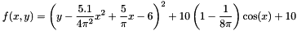

Added Gaussian mean zero noise to the above value.

Plot

Task 2
Spearmint Package was used to run the Bayesian Optimization for the above function.
Matern52 Covariance Function was used.
Expected Improvement Acquisition Function was used.

The spearmint package finds the Global Minima.

True Minima of the above function : 0.2430

Minima observed running Spearmint : 0.270087

Plot

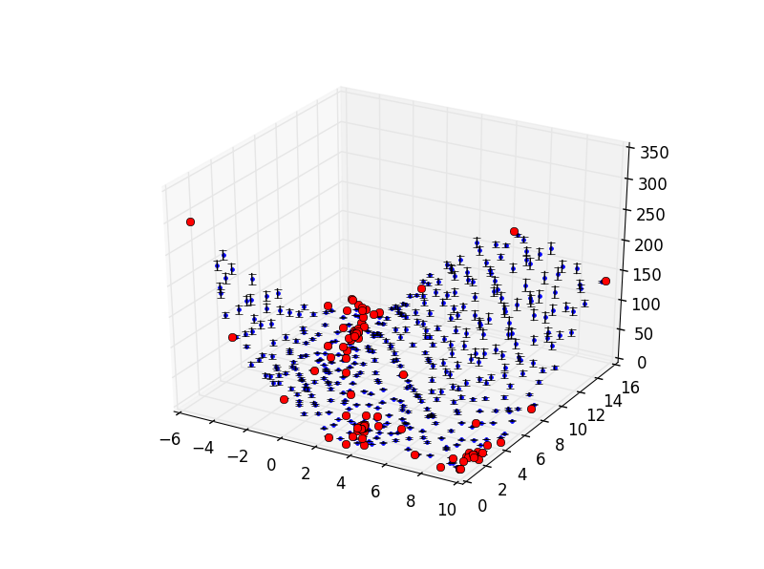

Task 3
Multiarm bandit optimization Matlab Code
clc;
K = 3; %No of arms
theta = [0.50 0.85 0.10];
T = 1000;
alpha = 1;
beta = 1;
s = zeros(K,1);
f = zeros(K,1);
x = 0:0.01:1;

for t=1:T
% Choose action.
theta_hat = zeros(1,K);
for i=1:K
theta_hat(1,i) = betarnd(s(i)+alpha, f(i)+beta);
end
[~, action] = max(theta_hat);

% Pull lever.
reward = rand <= theta(action);

% Update.
s(action) = s(action) + reward;
f(action) = f(action) + 1 - reward;
for i=1:K
y = betapdf(x,s(i)+alpha,f(i)+beta);
plot(x,y)
hold on;
end
hold off;
end

